Tab 1

Capstone Project: PROJECT NOTES
SUPPLY CHAIN MANAGEMENT

Table of Contents

1. Introduction
- Problem Statement
- Objective of the Study
2. Data Understanding
- Data Source and Structure
- Attribute Overview
3. Exploratory Data Analysis
- Univariate Analysis
- Bivariate Analysis
- Missing Value & Outlier Treatment
4. Key Insights
- Summary of Observations
- Business Implications
5. Data Preparation
- Encoding Categorical Variables
- Final Feature Structure
6. Model Building and Interpretation
- Model Selection and Purpose
- Model Evaluation Metrics
- Model Interpretation and Insights
7. Model Tuning and Optimization
- Ensemble Models
- Hyperparameter Tuning
- Final Model Selection and Business Implications
8. Conclusion and Recommendations

- Introduction of the business problem

  - Defining the Problem Statement
A well-known FMCG company entered the instant noodles market two
years ago. However, the company is facing a serious imbalance
between demand and supply across different regions:
- In high-demand areas, supply is insufficient, resulting in missed sales opportunities.
- In low-demand areas, excess supply is leading to inventory holding costs and wastage.
This inefficiency in distribution is causing operational losses and
dissatisfaction in the supply chain, prompting the need for better supply planning.

  - Need of the study/project
To address the demand-supply mismatch, the company aims to take a more data-driven approach to supply chain planning.
- Optimizing the quantity of product shipments to each warehouse based on regional demand patterns, thereby ensuring better alignment between supply and actual market needs.
- Reducing excess inventory in low-demand areas and minimizing stockouts in high-demand regions, which will ultimately lower operational costs and improve customer satisfaction.
- Leveraging historical shipment and demand data to build a predictive model that can recommend the ideal shipment weight for each location.
By achieving these goals, the company will be able to make more informed,accurate, and proactive supply decisions, leading to improved efficiency and overall business performance.

  - Understanding business/social opportunity
This project presents an opportunity to:
- Identify high-demand regions for focused advertising.
- Reducing oversupply and undersupply helps in minimizing inventory costs and maximizing sales.
- Success in this phase will allow access to the full company data, enabling the creation of a more advanced and scalable solution in the next stage.

- Data Report
- Data Dictionary
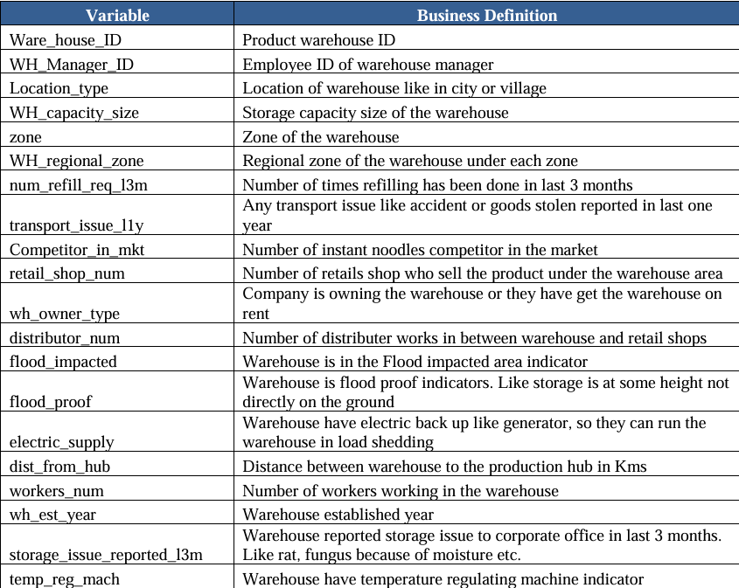
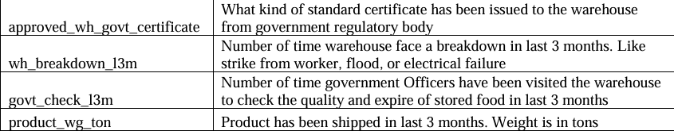
- Visual inspection of data (rows, columns, descriptive details)

- Overview of the Dataset
The initial steps to get an overview of any dataset is to:
- observe the first few rows of the dataset, to check whether the dataset has been loaded properly or not.
- get information about the number of rows and columns in the dataset
- find out the data types of the columns to ensure that data is stored in the preferred format and the value of each property is as expected.
- check the statistical summary of the dataset to get an overview of the numerical columns of the data.

- Displaying first 5 and last 5 rows of the dataset
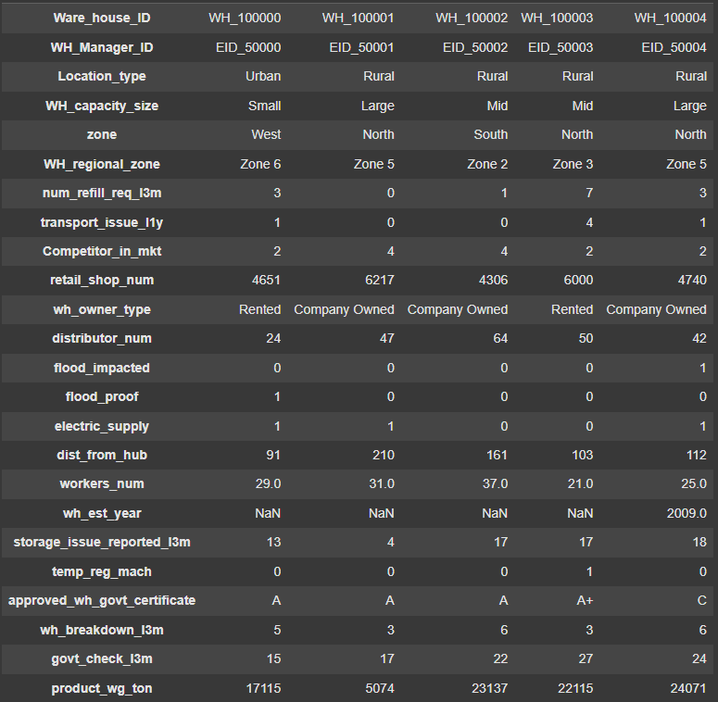
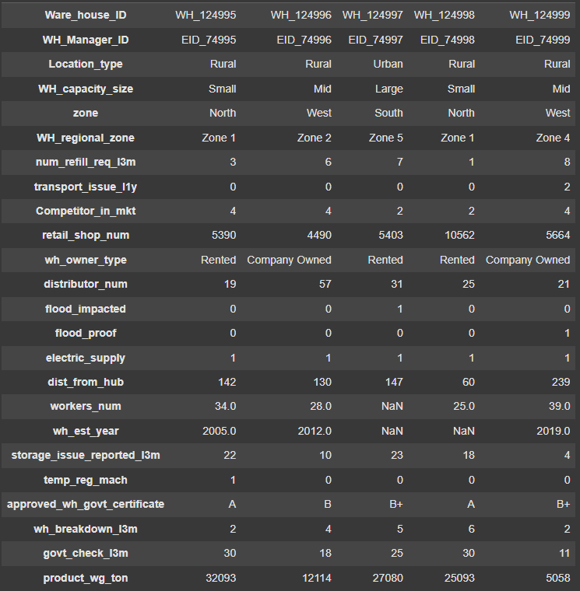

- The first few records show that the data appears clean and structured. However, we’ll inspect for missing or unusual values.

- Checking the shape of the dataset
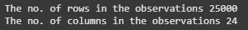
- The dataset contains 25,000 rows and 24 columns, indicating a sizable dataset suitable for analysis.

- Checking the data types of the columns for the dataset
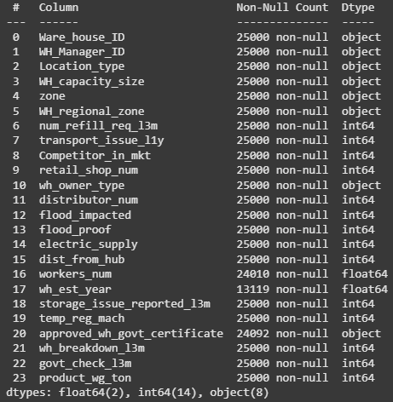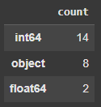

- There are a total of 24 cols in which 16 are numerical data types i.e., 2 float and 14 integer datatypes and 8 objects..
- In which some of them have missing values.

- Checking number of unique values
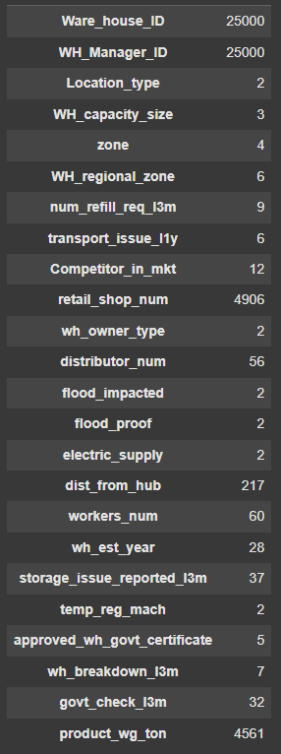
- The dataset has some columns with many unique values like warehouse and manager IDs, and others with only a few values like flood impact and owner type. This helps us understand which columns are IDs, categories, or numbers for analysis.

- Missing Value Check
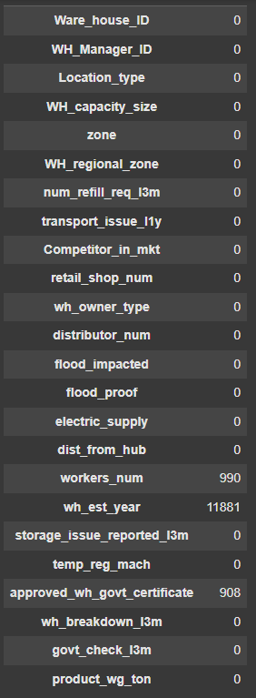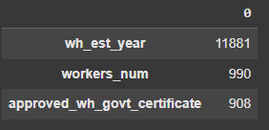
- Three columns have missing values in the dataset.
- These missing values will need to be addressed before further analysis or modeling.

- Statistical summary of the dataset
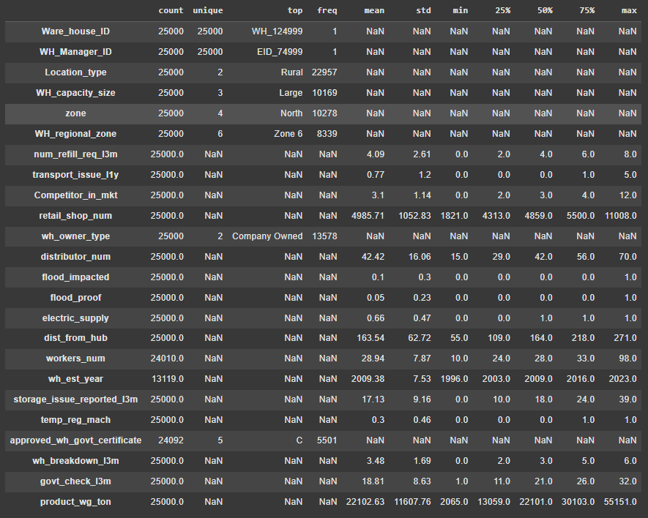
- Some features like product_wg_ton and retail_shop_num show high variation, which may need outlier handling.
- ID columns (Ware_house_ID, WH_Manager_ID) are unique for each row and not useful for analysis.
- Summary Statistics of Product Weight After Conversion
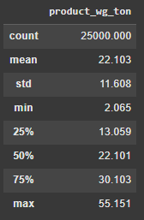
- The product_wg_ton column originally contained values in kilograms. It was divided by 1,000 to convert the units to tons, ensuring better clarity and consistency in the analysis.

3) Exploratory data analysis
- Analyzing the Target Variable
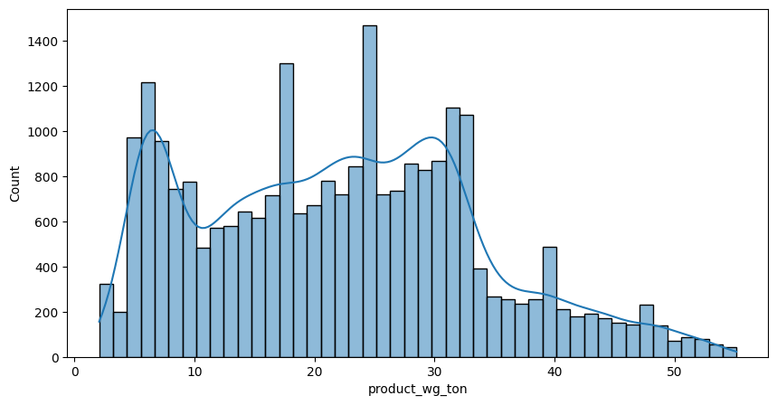
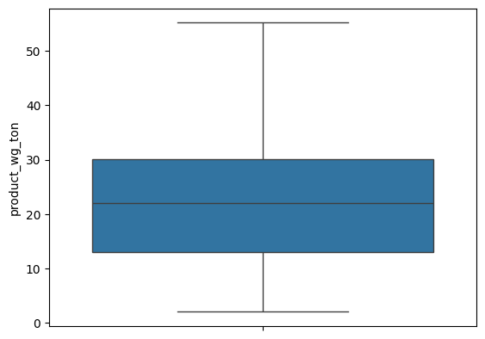
- Most values are concentrated between 0 and 30 tons.
- The distribution is not uniform and shows a right skew beyond 30 tons.
- The box plot indicates no significant outliers.

- Univariate Analysis
- For Numerical Values
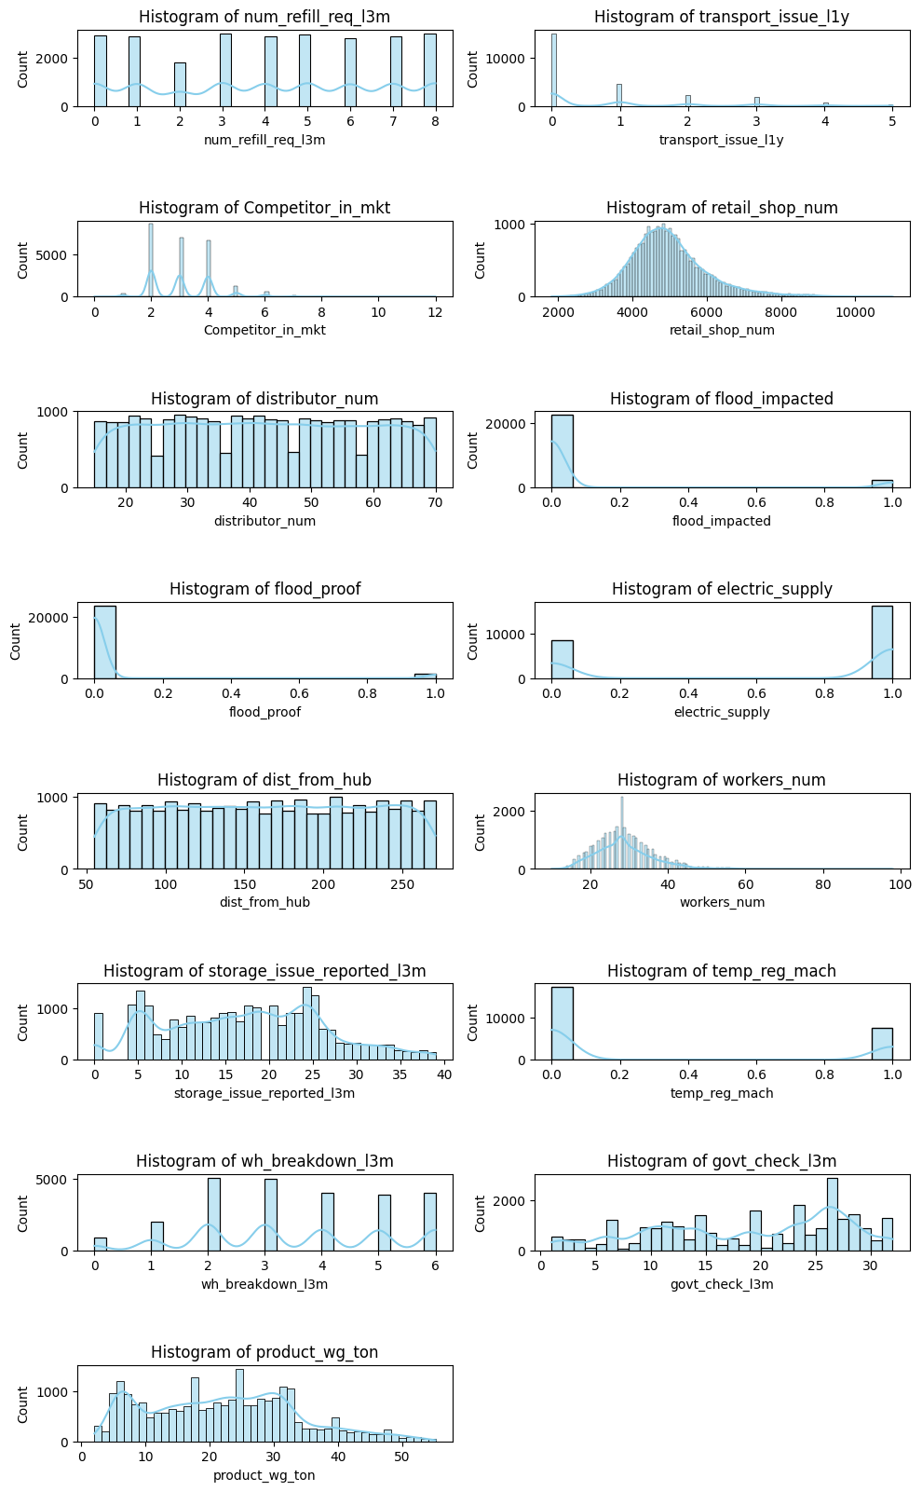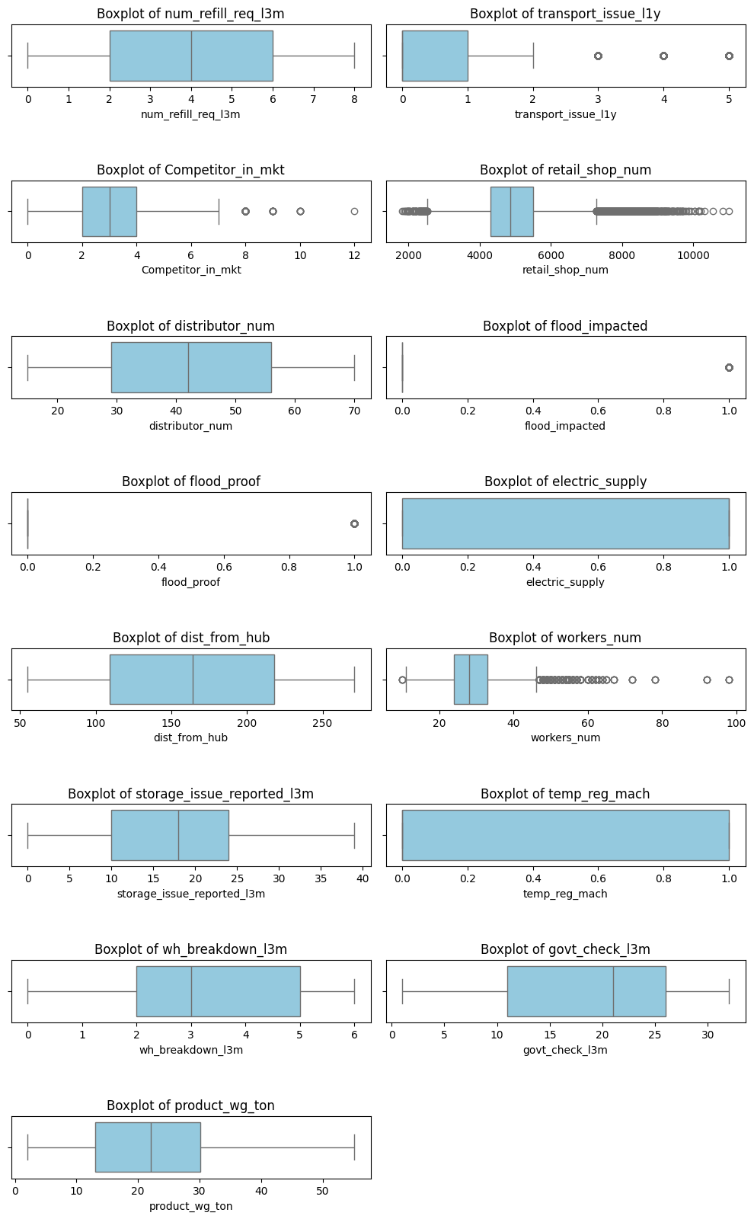
- Most variables like num_refill_req_l3m, distributor_num, and dist_from_hub show fairly uniform or symmetric distributions with no major outliers.
- Features like retail_shop_num, workers_num, and govt_check_l3m exhibit mild to strong right-skew, with visible outliers.
- The target variable product_wg_ton shows right-skewed distribution but no outliers as per the boxplot.
- Features such as flood_impacted, flood_proof, temp_reg_mach, and electric_supply are heavily imbalanced, with most values concentrated on a single category (0 or 1).
- Outliers are noticeable in transport_issue_l1y,
- Competitor_in_mkt, workers_num, and retail_shop_num via boxplots.

- For Categorical Values
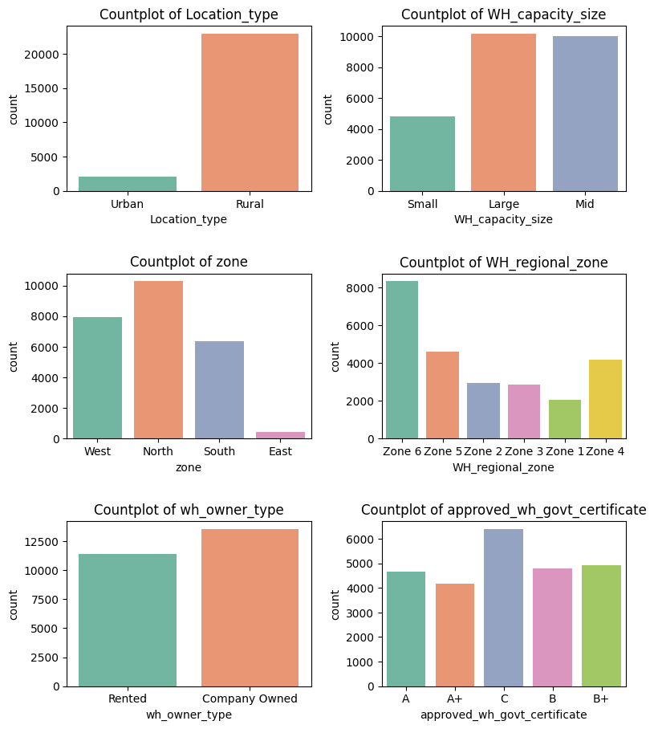\
- Location_type is heavily imbalanced, the majority of the warehouses are in Rural areas, with fewer in the Urban areas.
- WH_capacity_size is fairly balanced, with most warehouses being Large and Mid, followed by Small.
- In Zone, North and West zones have the highest number of warehouses, while East has the least.
- In Regional Zones Zone 6 has the highest concentration, followed by Zones 5 and 4.
- wh_owner_type has a slightly higher share of Company Owned compared to Rented.
- approved_wh_govt_certificate categories are evenly distributed, with category C being the most frequent.
C) Bivariate analysis
Categorical VS Target Variable
- In the exploratory analysis, boxplots were used to examine the relationship between the target variable product_wg_ton and three important categorical features: zone, Location_type, and wh_owner_type. These variables were selected due to their direct impact on supply chain planning and distribution strategies.
  - Zone: Helps analyze regional differences in shipment volumes. Certain zones might be consistently under- or over-supplied, revealing geographic imbalances in supply chain planning.
  - Location_type: Differentiates between urban and rural warehouses. Urban areas typically have higher demand due to more retail presence, and this variable helps assess whether shipments are aligned with expected consumption.
- These categorical features provide high-level business insights and help identify operational inefficiencies or regional mismatches in demand and supply.
- Product Shipment Distribution Across Zones
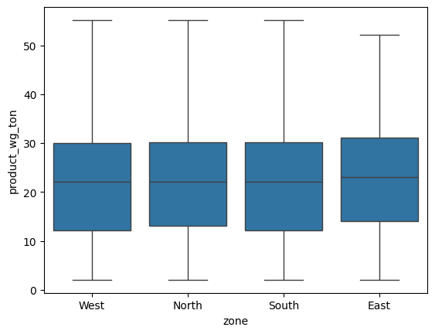
- The boxplot shows that there are no significant outliers in product shipment weight across the four zones.
- The medians for all zones fall within a narrow range of approximately 20 to 30 tons, indicating consistent shipment distribution.
- There is minimal variation between zones in terms of the quantity shipped.

Product Shipment Distribution by Location Type
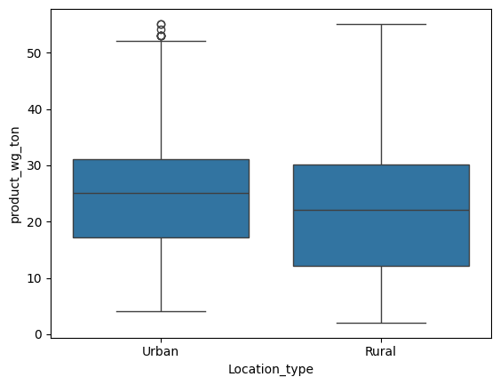
- The boxplot indicates a few outliers in the Urban category, while the Rural category shows a cleaner distribution.
- The median shipment weight for Urban locations is slightly higher than that of Rural, but both lie within the 20 to 30 tons range, suggesting overall consistency in supply between location types.

- Product Shipment Distribution by Warehouse Ownership Type
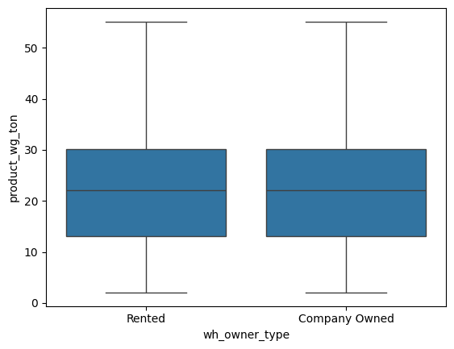
- The boxplot shows that both rented and company-owned warehouses have very similar shipment distributions.
- The medians are nearly identical, and there is no significant variation between the two categories, indicating consistent supply regardless of ownership type.

Numerical VS Target Variable
- dist_from_hub and retail_shop_num were selected for scatterplot analysis because they are continuous numerical variables that could logically influence the target variable.
- retail_shop_num: Potential demand in the area (more shops means more supply needed)
- dist_from_hub: Logistics factor (greater distance may affect shipping quantity or cost)
- Flood_impacted and transport_issue_l1y has too many zeroes so there will be no clear theoretical link to the product weight.
- Retail Shops VS Product Weight
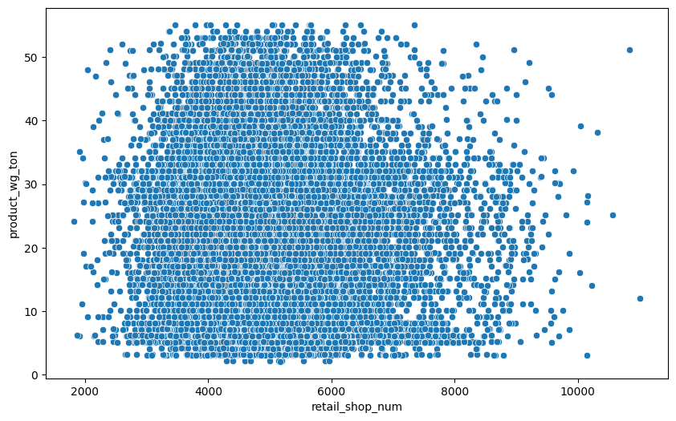
- The scatterplot shows a strong positive relationship between the number of retail shops and the product weight in the range of 3,000 to 9,000 shops.
- Beyond 9,000, the data points are fewer and more scattered, indicating less consistency.
- This suggests that areas with more retail shops generally receive higher product weight.

- Distance from Hub vs Product Weight
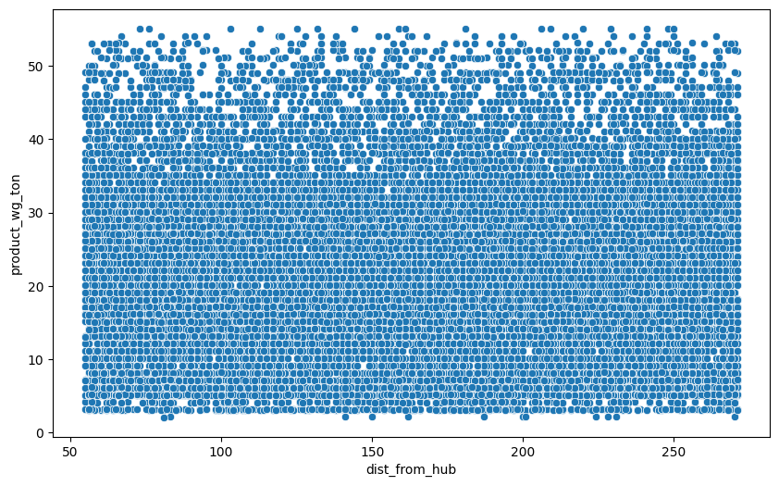
- The scatterplot shows a strong positive relationship between dist_from_hub and product_wg_ton, especially up to around 40 tons, where the points are closely clustered in a linear pattern.
- Beyond 40 tons, there is a slight upward scatter, but the overall trend remains consistent.
- This suggests that as the distance from the hub increases, the product weight delivered also tends to increase.

- Operational & Market Risk Impact on Shipment Distribution
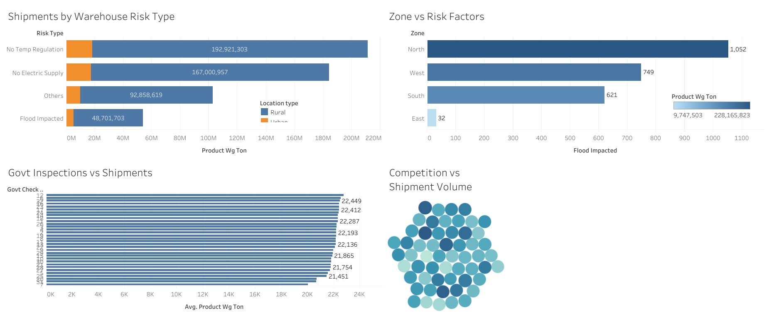
- The analysis reveals that shipments are significantly influenced by various risk and market factors.
- The visuals show that some warehouses without electric supply or temperature control still get high shipments, which may cause future problems.
- Flood-affected zones receive less supply, which means risk is being considered.
- Government checks don’t reduce supply much.
- Areas with more distributors handle supply better, even with more competitors.
Interactive Dashboard: View Tableau Visualizations Here
Explore how warehouse risks, market competition, and inspections influence shipment volumes across zones.

- Correlation for all Numerical Columns
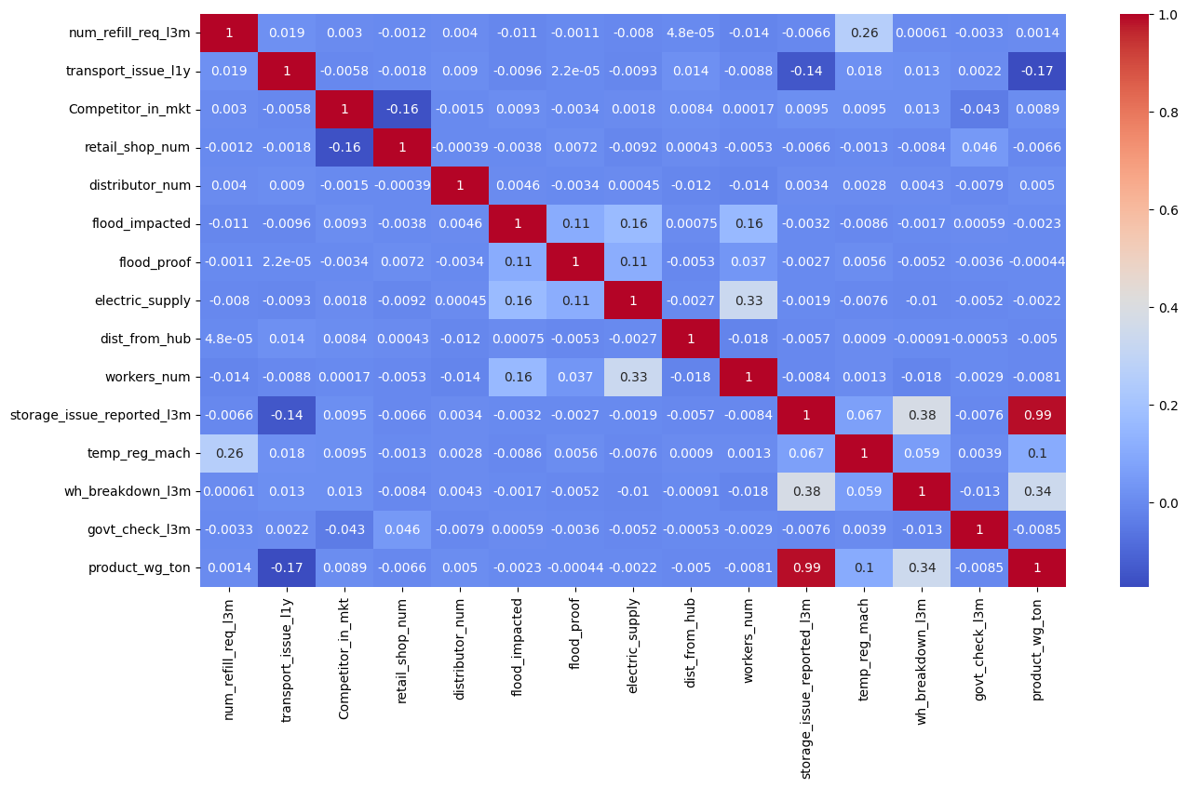
- product_wg_ton and storage_issue_reported_l3m have a very strong positive correlation (0.99). That means more stock leads to more storage issues.
- storage_issue_reported_l3m also has a moderate correlation (0.38) with wh_breakdown_l3m, and wh_breakdown_l3m has a weaker but notable positive correlation (0.34) with product_wg_ton. This may indicate that larger stock volumes could be contributing to more warehouse issues or breakdowns.
- product_wg_ton shows a mild negative correlation (-0.17) with transport_issue_l1y, suggesting that higher supply volumes may be associated with fewer transport issues.
- transport_issue_l1y and storage_issue_reported_l3m are also negatively correlated (-0.14), implying that areas with more storage issues might face fewer transport problems.

- Removal of unwanted variables
- The columns Ware_house_ID and WH_Manager_ID were removed from the dataset.
- These variables are unique identifiers and do not contribute any predictive or analytical value to the model. Hence, they were excluded from further analysis.
- Before dropping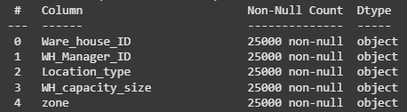
- After dropping 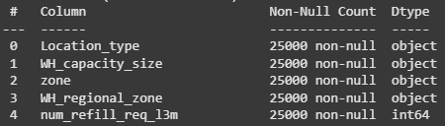

- Missing Value treatment
- Missing values were identified in three columns:
- 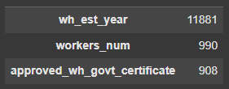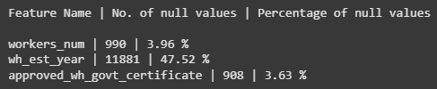
- wh_est_year had nearly half of its values missing (47.52%), so it was dropped from the dataset as it would be a risk.
- workers_num (3.96% missing) was imputed using the median, as it is a numerical variable and less affected by outliers.
- approved_wh_govt_certificate (3.63% missing) was imputed using the mode, suitable for categorical data.
- All missing values were successfully handled, and the dataset now contains no null values.
- 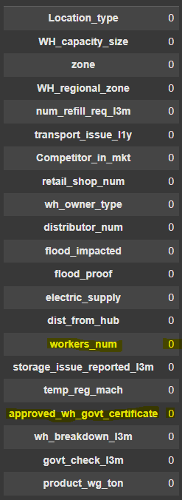
- Outlier treatment
- Outliers were detected during boxplot analysis in several numerical features like transport_issue_l1y, Competitor_in_mkt, retail_shop_num, flood_impacted, workers_num.
- The Interquartile Range (IQR) method was applied to all numerical columns. This technique capped values beyond the upper and lower bounds to reduce the extreme values without removing any records.
- After treatment, the distribution of affected features showed improved consistency, and re-plotted boxplots confirmed that outliers were effectively handled.
- Before Treating Outliers
- 

- After Treating Outliers
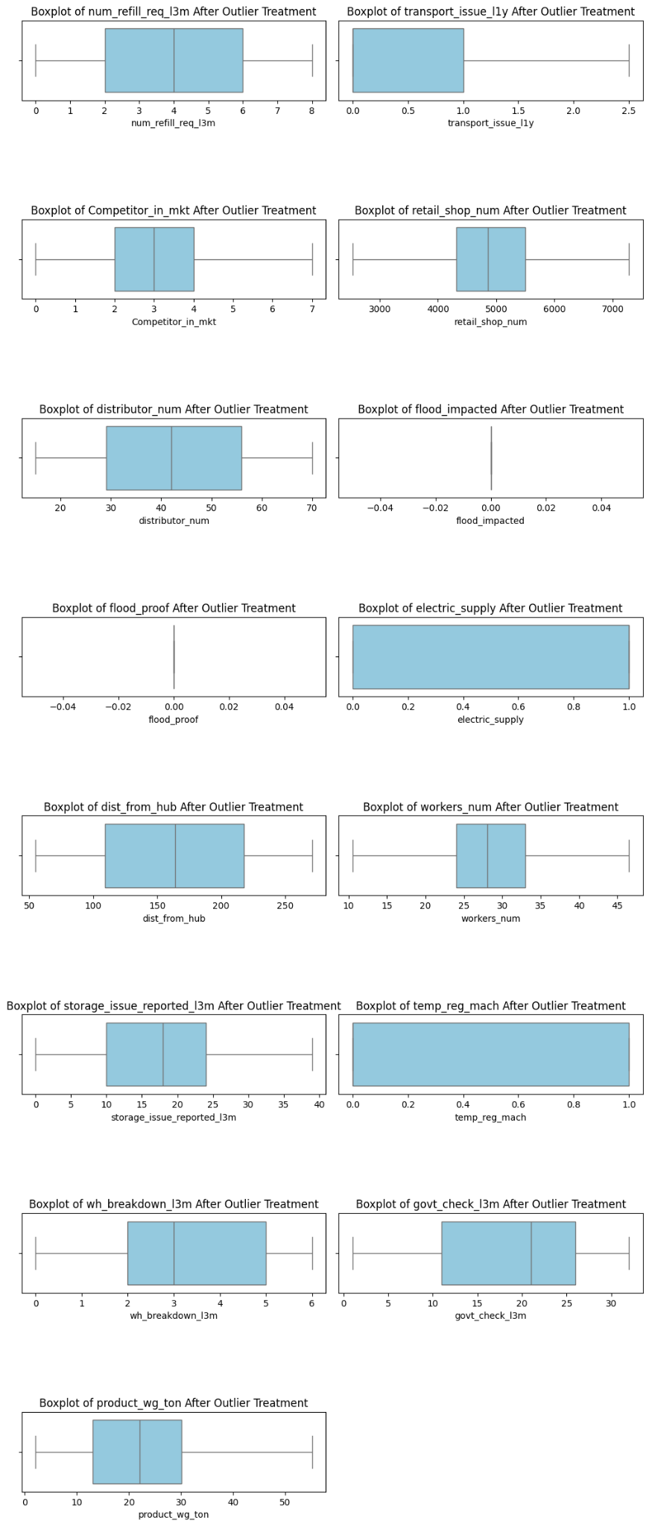

4) Business insights from EDA
- Is the data unbalanced?
- An imbalance in the distribution of shipments across different zones, warehouse types, or location types was observed.
- Some zones consistently receive higher shipment volumes than others, regardless of retail demand or infrastructure conditions.
- Urban warehouses may receive slightly higher shipments than rural ones.
- There is little variation between rented and company-owned warehouses, suggesting a uniform distribution strategy.
- Business Context & Recommendation
- In the context of the business, such imbalances could lead to:
  - Under-supply in high-demand areas, causing stockouts and lost sales.
  - Over-supply in low-demand areas, leading to excess inventory and storage costs.
- To solve this we can build a supply model:
  - Creating a predictive model can help estimate the optimal shipment quantity per warehouse based on historical data and demand indicators.
  - Clustering techniques can be used to segment warehouses based on risk, demand, and location to fine-tune supply chain decisions.
- This approach will help the company align supply more closely with actual demand, reducing inventory costs and improving customer availability.

- Any business insights using clustering
- High-demand clusters show areas where more supply is needed.
- High-risk clusters highlight warehouses needing better planning as in flood zones or far from hubs.
- Mismatch clusters reveal where supply doesn't match local demand.
- Helps in better supply planning, inventory control, and targeted marketing.
- Any other business insights
- Uniform Supply Across Zones: Shipment volumes are similar across zones, which may not reflect actual demand variations.
- Urban vs Rural: Urban warehouses receive slightly more supply, aligning with higher retail density.
- Mismatch in Demand & Supply: Some warehouses with high retail presence receive less supply, leading to potential stockouts.
5) Data Preparation
- One Hot Encoding was applied to categorical variables such as zone, Location_type, wh_owner_type, and WH_regional_zone.
- Label Encoding was used where appropriate for binary categories like WH_capacity_size, approved_wh_govt_certificate.
- All variables are now numeric and are suitable for most ML models.
- There are no missing values found in any column.
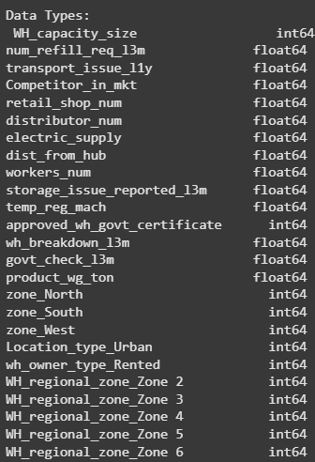
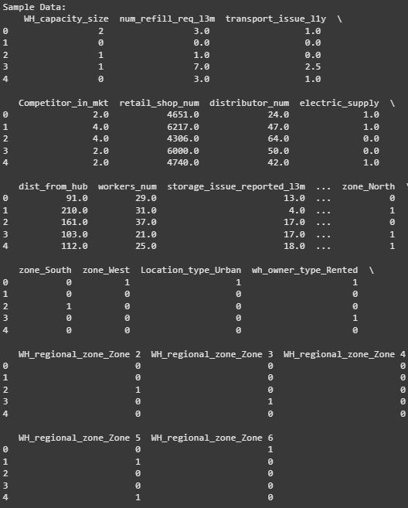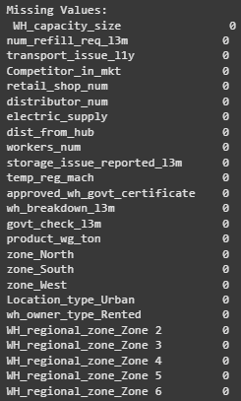

- Train-Test Split
- Dataset split into Training Set (80%) and Test Set (20%).
- Size of the dataset:-


- Feature Scaling
- Standardization applied to numerical features to normalize the scale.
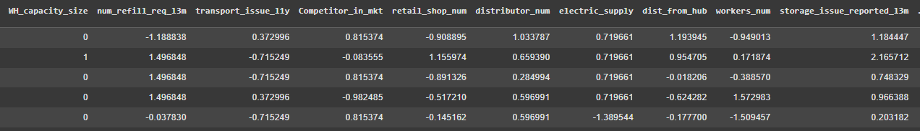

Project Notes - 2

1) Model Building and Interpretation

- Training a Regression Model

- Linear Regression Model
- Selected as a baseline model to predict the target variable (product_wg_ton).

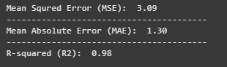

- Linear Regression shows excellent performance on the test set.
- The R2 value of 0.98 indicates that the model explains 98% of the variance in the target variable, it is a very strong fit.
- Low MSE and MAE values indicate high prediction accuracy with minimal error.
- Sets a strong baseline for further model comparison and tuning.

- Visual Evaluation: Actual vs. Predicted Plot

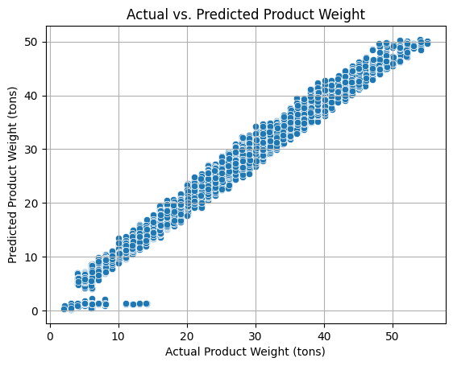
- Points are closely clustered around the diagonal line, indicating a strong linear relationship and high prediction accuracy.
- Some outliers are visible at lower weights (0–15 tons), which could be examined further.
- Ridge Regression
- It helps keep the model stable by reducing the impact of very large coefficients, especially when some features are closely related to each other.
- Ridge Regression gave almost the same results as Linear Regression:
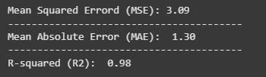

- As it shows the same performance as Linear Regression which indicates that overfitting is not a major issue in this case.

- Ridge Coefficient Visualization

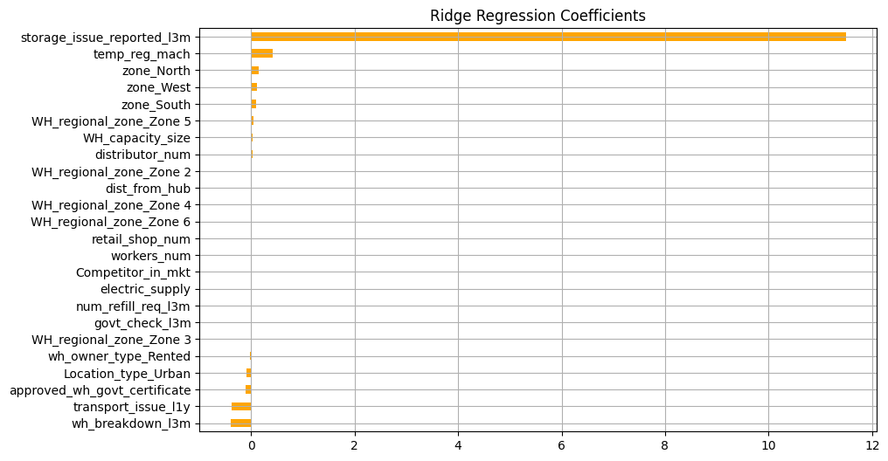

- storage_issue_reported_l3m has the largest positive coefficient, indicating it is the strongest predictor of product_wg_ton.
- All other features have much smaller coefficients, suggesting a lower individual impact.

- Actual vs. Predicted Plot (Ridge Regression)

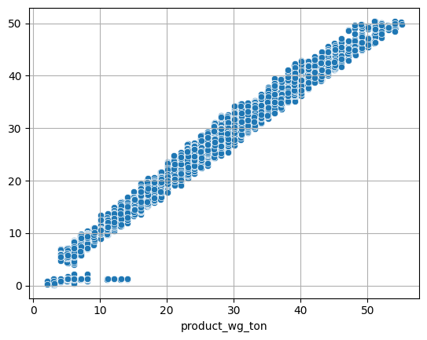
- The Actual vs. Predicted plot confirms this visually, showing near-perfect alignment between predictions and true values.
- This validates the consistency of both models in predicting product_wg_ton accurately.
- Even though Ridge didn’t improve accuracy, it’s still useful for highlighting key drivers of product weight.

- Lasso Regression
- Lasso helps prevent overfitting and deals with similar features by reducing or removing their impact, making the model simpler and easier to interpret.
- Lasso Regression gave slightly lower performance than Linear and Ridge models.
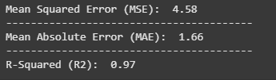

- Actual vs. Predicted Plot (Lasso Regression)

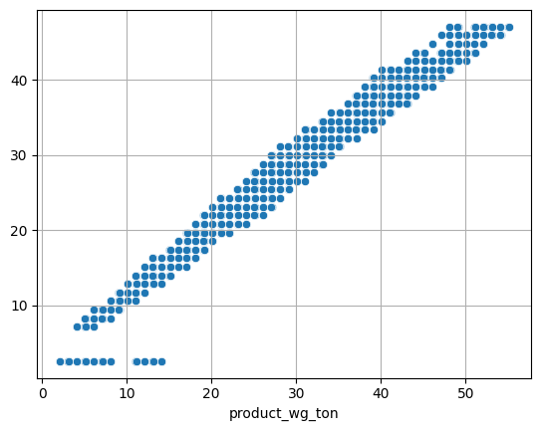
- The scatter plot of actual vs. predicted values looks very similar to the previous models, showing that Lasso still predicts well, though with a bit more error.

- Support Vector Regression (SVR)
- SVR achieved the highest accuracy with R2 = 0.99, with the lowest error values among all models.
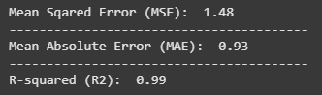

- SVR has outperformed Linear, Ridge, and Lasso models in terms of accuracy.

- Actual vs. Predicted Plot (SVR Regression)

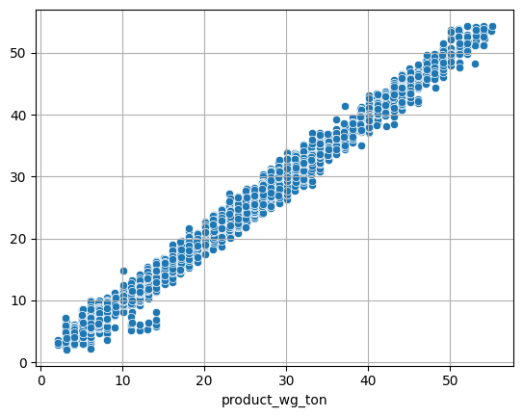
- The scatter plot is mostly similar to previous models.
- While its prediction plot is nearly perfect, a few scattered points at the lower range suggest minor variance in low-weight predictions.

- Random Forest Regressor

- Random Forest Regressor has also performed very well, even better than SVR in terms of error metrics.
- This is the lowest error among all models tested, indicating excellent predictive power.

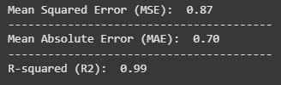

- Random Forest is a very strong model for this dataset, with top-level accuracy.

- Actual vs. Predicted Plot (Random Forest Regressor)

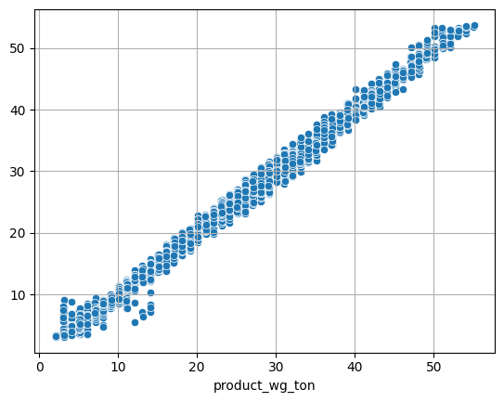
- The plot shows a strong match between actual and predicted values.
- A few predictions in the lower right region are less scattered than in SVR, showing slightly better consistency in low-weight predictions.
- This suggests that Random Forest handles both high and low ranges very effectively.

- Model Comparison (R2 Score on Test Data)

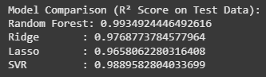

- Random Forest gave the best results, with an R² score of 0.9935, making it the most accurate model overall.
- SVR followed closely with 0.9890, also a very strong performer.
- Ridge Regression did well with 0.9769, while Lasso was a bit lower at 0.9658.
- Overall, this shows that advanced models like Random Forest and SVR handle this data better than the more basic linear models.

2) Model Tuning and business implication

- Ensemble Modelling (Random Forest Regressor)

- To improve prediction accuracy and avoid overfitting, we used Random Forest, an ensemble model that combines many decision trees.
- This model gave excellent results even before tuning and was the best fit for our business problem.
- Model Tuning (GridSearchCV on Random Forest)
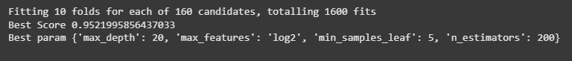

- We applied GridSearchCV to carefully tune the model. This involved testing 160 different parameter combinations using 10-fold cross-validation.
- The above parameters significantly improved model performance.
  - Best Cross Validation R2 Score: 0.952
  - Test R2 Score: 0.955


Plot of Train vs Test Performance
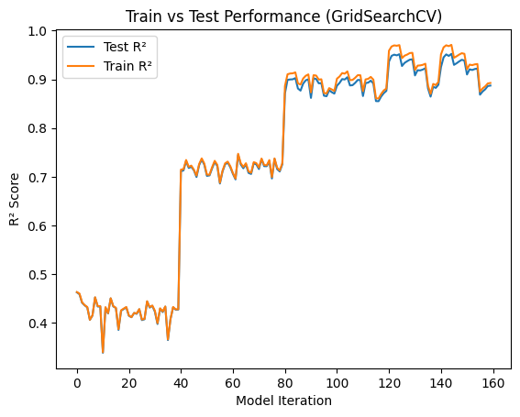
- This plot shows how the model performed on training and test sets during hyperparameter tuning. The closeness of the curves indicates low overfitting and a stable model.
- This makes it reliable for predicting the right shipment weight for each warehouse.

- Interpretation of the most optimum model and its implication on the business

- The tuned Random Forest model was chosen as the final model because it:
- Had high accuracy
- Was reliable and stable across different data splits
- Worked well with both numerical and categorical features

- Business Implications

- This model helps the company to predict the right amount of product to send to each warehouse.
- Avoid under supply that causes stockouts and lost sales.
- Avoid over supply which causes extra inventory and storage costs.
- Make data-driven supply chain decisions that reduce costs and improve service.

Conclusion
- Out of all the models tested, Random Forest performed the best in terms of accuracy and consistency, even before tuning. So, I focused only on tuning this model using GridSearchCV. This helped improve its performance further, giving a strong R2 score on the test set.
- As Random Forest already met the technical and business requirements, tuning of other models like SVR, Lasso, or Ridge was not needed. This approach saved time and enabled the use of a reliable and interpretable model for supply planning.

